NOTES on LITERARY MODERNISM

THREE IMPORTANT ASPECTS OF MODERNISM

MOVEMENT
…of people across regions and countries, from rural to urban lives, and from past values and ways of life into new ideas, technology, and culture…

ALIENATION
…of self from others, nature, home, spirit, and self…

TRANSFORMATION
…of human relations, expression, culture, social organization, dreams, and stories…

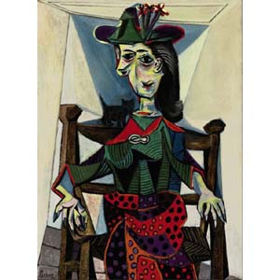
TEXTUAL CONNECTIONS
On our reading list, modernists with roots in the American South (Katherine Anne Porter, Zora Neale Hurston, William Faulkner, and Richard Wright) dramatize these aspects in various ways, touching on gender and race relations and major transformations in their characters’ lives.
Pablo Picasso, Portrait of Dora Maar (1937)

Similarly, John Steinbeck bases his fiction in the American West and Southwest, writing from strong roots in Depression-era protest and stark social realism.

In contrast, Ernest Hemingway’s modernism is uprooted from nation and home, with characters and settings ranging the world, from Latin America to Europe to Africa. For this reason, Hemingway’s “Hills Like White Elephants” creates a nice transition from the United States to international fiction.

In much the same way that Pablo Picasso (1881-1973) expresses modernist fragmentation and relative perspective through his paintings, modernist writers like Hemingway, Jorge Luis Borges, and Albert Camus experiment with the elements of fiction to create new literature, ranging from spare and brittle to abstract and avant-garde. Some critics even think that Borges’ puzzling texts point beyond modernism.

RELATED TERMS, IDEAS, AND MOTIFS
HEMINGWAY → minimalism, distance, estrangement, expatriation
CAMUS → anti-colonialism, solitariness, existentialism, anxious freedom
BORGES → mysticism, anti-fascist humanism, textual play, post-modernism

